Catherine’s closing words and Simon talk 5/1/2024
The Giant of Faith Awakened Acts 2:42-49
Thank you! We would like to thank everyone who was involved in our farewell service and celebration, last Sunday. It was a poignant time for us as a family and we were touched by the gift of the painting and by Mark’s moving words about “Mrs Vicarage” and our time here. We have been moved by the cards, notes and letters that we’ve received, and for the gifts – some of them quite personal. Thank you to everyone who made it such a memorable morning.
Several people have asked if they can have a copy of Catherine’s words from the close of the farewell service. Many have asked about a recording of the sermon. Many people noted, rightly, that Catherine got the last word in giving her speech at the end of the morning!
__
Catherine: 15 years is a long time. I look at it in terms of these 3 gorgeous boys in front of me. When we arrived here Dan was 4 – and now look at him. Luke started in year 3 at the Junior School and met his “boys” almost straight away and they are still best friends now – we all love them. Jacob found his place in his music tech and in Icthus and is now making a real success of his work and getting married – we love Freya and she is becoming part of the family.
So I wanted to thank you for being part of that journey. I don’t want to single anyone out but there are certain people that have made such a difference. People like all the youth workers and particularly people like Jill Mace and Niki Ford who were supporting the boys week after week on a Tuesday. And Rosie James who frequently turns up at our door with flapjacks just when they are most needed. Others who have responded to God’s prompt and left little gifts and notes on the doorstep – you know who you are.
Thank you to those people who have walked alongside our mess and chaos, we have muddled through together and you have accepted us warts and all – you know who you are too.
To My Explorers Team – you are awesome – our lockdown meetings in covid were a highlight of my week. You are amazing people and I have loved being in a team with you.
To the café team – thank you for your patience – not only did you accept Luke into the team and love him, you were very patient with me on a Saturday morning when I did not always get it right. I should add that the irony of your 18 year old son teaching me how to clean a toilet was never lost on me.
This to me highlights that this time is about building relationships and being with people and going through our time here with people who love and support us and not about the places.
We have always tried to do be real and to follow what God has called us to do – that has not always been easy and sometimes caused upset and not been easy. But we have always tried to stay true to what we felt was right.
With this in mind I wanted to again thank you for bearing with us, for being an amazing people in community. However, mainly I wanted to thank these lovely boys – for putting up with us and for being our best achievement of the last 15 years.
--
Simon: As this is my closing talk after nearly 15 years here and bringing our family up in the Godalming area, I hope that you will indulge me in looking back, considering the present as Godalming Minster and glancing to the future.
It has been an honour and a privilege to be part of shaping people’s lives for the better, connecting with communities, speaking into national, international and local situations, guiding us through Brexit, the dilemma for some of women Bishops, navigating national CofE changes, working with schools, civic leaders, several mayors and changes of parish councillors, Hambledon village shop as the managers have changed – sadly through death – and the changing ownership of the village pub as a centre of village life. We’ve faced down a global epidemic and the shock of deaths in this church community.
It has been a privilege to walk with you in your stories of life; some of them deeply personal and I thank you for your trust in sharing them with myself and other clergy present here today as we’ve seen people’s lives restored in Christ through unchanging Scripture and by the Spirit of God at work. There are so many clergy here today from the past and present and we as a family are deeply grateful to each of you from the past 15 years who have made the journey today. I cannot quite believe that Rev James Ellin has arrived from the North with a cut out from a pizza box for his collar! So many people have gone from here in the past decade and half to lead churches, become evangelists, or take up charity roles.
In the beginning… how we got to 2025
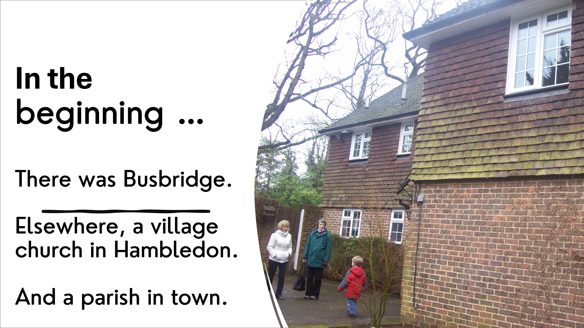
Let us tell a story by returning to the beginning. In the beginning there was Busbridge, elsewhere a village church in Hambledon and a parish down the hill in the town. At interview, the conversation centred on the view that I’d need to lead a building project to extend Busbridge Church. I thought, ‘is that extending a building, or building a people of God’?
The opening image shows a young son meeting Frances and Lynda. The space behind him no longer exists. It’s where the front of the Old Rectory Minster Hub sits. It is a picture of beginnings.
As our boys have grown, they’ve interacted with people who have shaped their lives; people like Rev John Postill and his love of Hull FC, and Rev David Mace and his time and care for our boys over the years. When we arrived, one son loved all things Arsenal. He was soon converted to Man. United!
The beginning in 2010 was two sermons from the passage today, Acts 2:47. One in Busbridge, the other at the Hambledon harvest festival. I titled it ‘Imagine Awakening the Giant of Faith’. The theme was that it was time for Busbridge to come off the hill for the good of the town and for Hambledon to re-engage with its village for the good of all people.
Jeremy has just mentioned that I could stand for Parliament! I am nervous today with our MP in the second row and the Rt Rev Michael Baughan in the front, next to the Lord Lieutenant of Surrey! Back in 2010, my opening words were – from my original sermon notes:
“I feel like a political party leader at conference, about to take the stage. Every word will be interpreted. Perhaps you are here to hear if your favourite service is about to change? Perhaps you think my listening is over?” We’re here to be shaped into an Acts 2 church.”
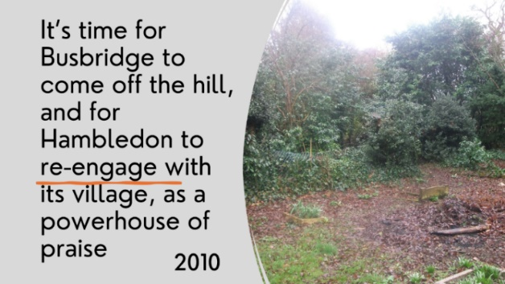
The picture from Busbridge churchyard back then shows a bonfire in the churchyard, right next to graves. It seemed to me to be a message that the church and community needed to reconnect. People needed their churchyard back, and some years later we did more than that when we gave the community a path off the road and the Yew Tree Café.
I shared a three-point vision from Acts 2, based around an unfinished Turner painting of Goring windmill. It was a painting of a work in progress. The message was about becoming a beacon of light in the area for the good of all people.
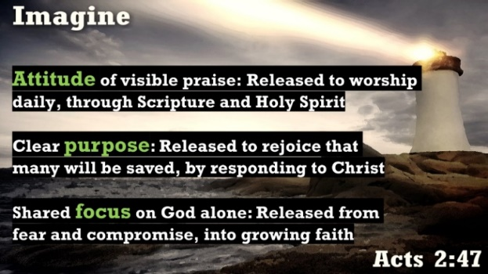
Those three-points of attitude, purpose and focus were, without any of us knowing it, a precursor to our Minster vision of following Jesus, loving people and renewing faith!
We were there nearly 15 years ago, without knowing it, but God knew. Over those years, the Minster has come a long way towards becoming devoted like those Acts 2 people.
From the beginnings in 2010 we’ve become dealers in trust, dealers in changed lives and dealers in secure hope.
1 Dealers in trust in an untrusting age: cultivating the core of belief
The Church is in decline in the West.
- Riven by dispute.
- Torn by failings.
- Ripped by shifting sands of what is to be believed.
It isn’t surprising that people don’t see the Church bringing comfort or the transformative power of Christ. It’s just another organisation amongst organisations to distrust. But the blueprint that Luke gives us is a church that isn’t exceptional but one of everyday faith lived out imperfectly by real people being real with one another. They do that because they are devoted people – or ‘all in’:
- devoted to Scripture and teaching
- devoted to people
- devoted to one another
- devoted to worship.
The church that grows is the church that, like the past 15 years here, is being one that reframes success away from mirroring the World and into mirroring Acts 2. A diverse group gathers in Acts 2, but they unite in belief. They put their different pasts below their common future. Success isn’t buildings, individuals or opinions.
It is a growth that began long before the past 15 years. All I’ve done is act as a steward of the present. Rev Ian Gordon Cumming brought his preaching and military service; Rev Peter Sertain added his evangelical and charismatic background; JP and Jack Creswell brought a focus on people and strong Biblical teaching; Rev Blizzard Barnes, Jolyon… so many clergy each brought orthodox, historic faith in Scripture, living in the Spirit and the love of God for people through Christ. Perhaps the most memorable is Rev Elton, who would drive around Hambledon in his tiny black car far too fast. He didn’t know anything below 50mph. I believe he took many funerals! He also loved Scripture. Busbridge and Hambledon was founded on a history of orthodox faith, love of Scripture and belief in the risen Christ. It goes back years, decades and centuries and the result is before us today.
When people see ‘all in’ faith in action they see a reason for trust in an untrusting age.
People may not agree with us in our faith, but the comments I have had over the years is that they respect our integrity. We walk what we say we believe. It is infectious and changes how people deal with life.
I remember the conversation I had with someone who saw what was happening. Clare was the treasurer back then and this couple wanted to give a donation. “We want to give a significant donation because we believe in what is happening here.” I thought this might be about £5,000 so I went for a cup of coffee. They wanted to give £50,000 in the first instance. It would be for a music-worship pastor. The PCC was worried they might want to control it, create the job spec, be on the interviews. Those were valid queries but the couple were not about being in control. “No,” the couple said “we trust you. We trust what is going on. You make the decisions.”
If we don’t trust, and we don’t truly believe, then we will seek to control. The Word of God through Acts in clear: when we learn to love God, we are released into a deep form of trust. My one cry to you for the future is not to close down to much into saying what you want from the next Rector. Trust God in who He is calling to you.
2 Eagerly teachable: dealers in changed lives
The Christians were secure in their belief, sought to learn more and were devoted to radical commitment to others. They became widely known for their generosity in an age when generosity was seen as a weakness.
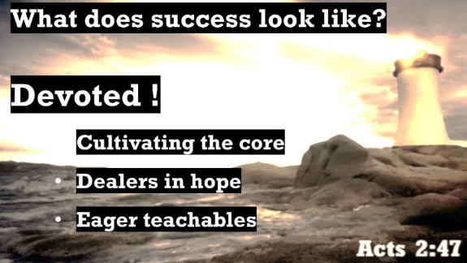
Transactional Honour was the code of the Greco-Roman World around Acts 2. You did things in expectation of getting something back, but deep down we know all of us need relationship, trust and integrity. Luke’s description of ‘all in’ integrity is so normal to us now that we think of it as the usual way of life, but it is a Christian foundation that has become normal in the World around us.
The word used here for generous is worth noting for our own lives. It’s the only place in Scripture that the word is used. It means ‘simple living’. It wasn’t merely about money but about a way of life and an outlook that was teachable. It wasn’t about what people brought to the church but what could be learnt from the Apostle’s teaching and lives.
We’re a church of teachable people.
Teachable people can sometimes seem a bit simple, or naïve. That’s exactly what the Church became known for. By the 2nd Century AD a Greek author penned a novel about a man called Peregrinus Proteus. The story was of someone who saw the Christians’ teachable attitude as something to take advantage of. Proteus became a preacher. In the story, he led a church and used this to change the teaching to accommodate himself to amass money from the people. Then in the 4th C it really happened. A Roman Emperor named Justin the Apostate saw that the Church was full of generous people. They did things like set money aside for the poor. He saw that he could take advantage of the Christians and shift their thinking to give him the money. He would use it to protect them – by rebuilding the Roman military.
In being teachable, we need to be able to discern that which is of God. Secure belief through knowing that Christ is Risen, Scripture is Holy and that the faith is secure means that we can walk with confidence alongside people who disagree with us. We have no fear of needing to withdraw or become defended. The Minster is full of people whose secure faith leads you towards even the most difficult people in love, not away from them. Every person is seen as created by God, and that shows in how you care for people across this area.
Being teachable means that the giant of our faith is awakened to when it is being usurped, altered or used for its own ends or by well-meaning misunderstandings. It is why, when we see mistakes; we apologise and we seek to make amends. Luke makes no mistakes in his inspired writings and he locates the story of Annanias and Sapphira in Acts 5:11 as an example of people having a sense of using the faith without the depth of being changed by faith. The lesson is that the Living God sees into each of our hearts. It is why we have such excellent safeguarding team in Jenny and Sarah. Listen to them because they know they bring safety to the fore for the Lord.
God makes His plans known.
A teachable people of Jesus Christ know that the Living God makes His plans known plainly through Scripture, Spirit and the past. We test this through Scripture. Perhaps the greatest example of this over the past 15 years was the night of April 30th 2014. Graham Sheldrake is here playing the drums today, and many of you are present who remember that night and the day before it.
Busbridge and Hambledon Church was going it alone. We were still on the hill. On April 29th and 30th, several people were awakened to pray. Some were awakened to hear a thought in their heads. Others were awakened with a Scripture to remember. Some of you were in Godalming, others were elsewhere. One person was, if I recall correctly, on a different continent and in a different timezone, but awakened at the same time. The message was clear: we were to work with Godalming Baptist Church for the sake of the Gospel, to bring good things to people of this town. We had a faith that was secure and awakened and now it was time to work with others in this. We were not to work alone.
The next morning, I received a vaguely written email from the pastor of Godalming Baptist Church, Rev Marcus Dickenson. Marcus and I did not know each other particularly well, so it was a surprise to receive it. He wondered if we might begin to work together and look at unity. I picked the phone up and Marcus shared that members of the Baptist Church had also been awakened that night and they’d spoken to Marcus. Graham is one of those people.
What do you do when the Holy Spirit prompts in such a miraculous manner? It is obvious! We formed a committee to talk about what we might do. Committees for talking are a great mechanism to get absolutely nothing done. With the benefit of hindsight, it was a mistake. Perhaps the timing wasn’t quite right back in 2014. That consideration is now something for my successor at the time when the new Baptist Pastor will start in February of this year. All those people, all the information written down, all prayed through and tested with Scripture, cannot have been mistaken. Perhaps it was then, unknown to us, that the genesis of Godalming Minster was being prepared by God?
The Acts 2 Church knew what we know: that being teachable by God means the Minster is not an institution nor buildings. It is not about personal opinions or preferred styles. It is about the one, true Living God who calls all to be freed from broken living. If we are honest with ourselves, we know that life is a mess. A faith that leaves people within that mess is not a belief in the power of the living God of transformation who awakens people at night, calls them by name, and gives them a vision and purpose beyond anything they could imagine for themselves. We know the God who brought Christ back from the dead.
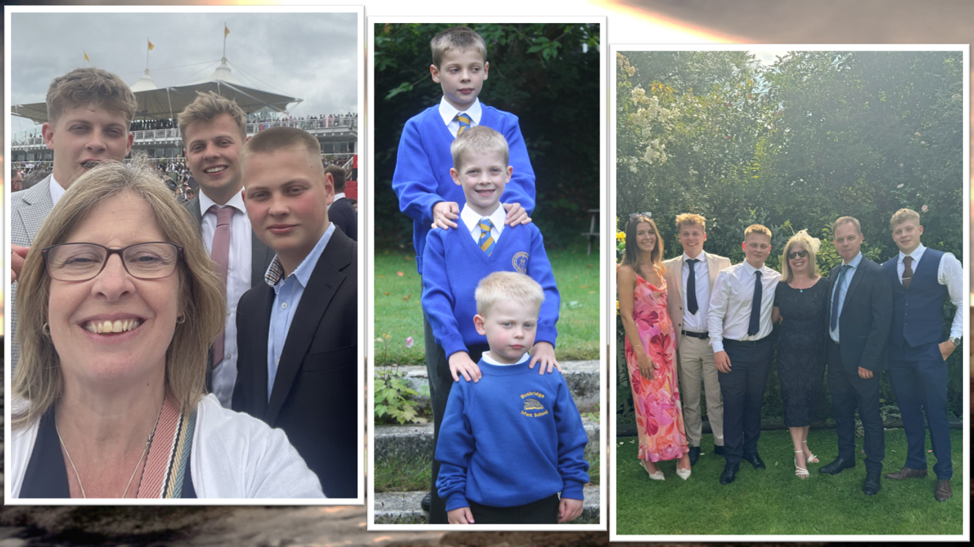
3 Dealers in Hope
What a message this is. That the Christian church here in the Godalming area is alive and full of hope.
Many years ago, I was standing on Kingston Station in SW London. A stranger approached me and offered me what I suspect were drugs. He called it a free sample. I was entertaining a stranger, unaware of their true motivation or what form of hope was written in their soul. It became obvious it was an empty hope. No, I didn’t accept the free sample!
Sometime after that, I was in a nearby town and going back to my car. A group of people had set a stall up near the carpark. They were offering books about all sorts of spiritual matters. I was intrigued, so I approached them. It turned out that they wanted an argument and deep down, what they offered was an absence of hope. They seemed more interesting in destroying my hope than offering anything better or deeper or more profound.
The hope we offer in Christ is a living hope.
It flexes through the hard times and it carries us through the darkness. It illuminates us in a way that others see. It empowers us to walk with people we disagree with and to approach people in need. The hope we carry is one of the Cross. It enables those who have returned this morning to know they have a connection here, even if they have not been here for a decade or more. Our hope passes through time and circumstances.
When Luke says that he’s writing a sequel, he does so with a purpose in mind. If you are like me, you’ve watched many sequels on tv over Christmas. Luke’s sequel isn’t better than the Gospel he wrote, because it isn’t really a sequel. He wrote it for a different inspired purpose: to demonstrate that God’s people are Christ’s Church and that Christ’s people have the power of the Holy Spirit within them.
I don’t think I’ve ever found a sequel that’s better than the original. Yet we all watch the sequel in hope that this one will be different! So many people are looking around life for sequels – something more, something better. If that is you, then look around you today at what Godalming Minster is. 400+ people together as a community of loving grace. It is as attractive and beautiful as that Acts 2 description.
Devoted in the passage means ‘to attend to constantly’. We, Godalming Minster, have attended to God. Devoted to Him, the choral congregation has welcomed me and shown me grace and kindness. I have come to truly appreciate you and the worship that is offered to God. Devotion means that we constantly offer hope because of the hope in Christ that we know. Devotion means that we are teachable and do not believe that we are the focus as an individual. Devotion means that we offer a way to trust which this town and area needs. It is a trust that is earned and needs to be constantly renewed by loving care and actions.
4 Acts 2 today – Godalming Minster

As I close, devotion means to Catherine and myself personally, that we are grateful for the past 15 years and we are most grateful for the family that we have brought up here. We love our sons. We love each other and we love each of you. Together, all of us have built something important here as Godalming Minster.
This is going to sound a little bit like something from Revelation:
- Hambledon, I have seen your devotion to deep generosity, care for the village and Biblical and charismatic faith.

- St Mark’s, I have seen your utter devotion to walk with people who are often bruised and hurt. Your kindness has no walls.

- St Peter and Paul’s, I have seen your devotion to maintain the light of deep, historic worship that is timeless and seeks to glorify God.

- Busbridge, I have seen your devotion to excellence, quality and doing things well.
One Church, One Faith, One Scripture, One Lord
Together, we are One Church, not different churches. We are One in Christ. The Minster is One Church, One faith, One Scripture, One Spirit and it glorifies the One Risen Lord Jesus Christ. What a people of God you are. What an incredible staff team we have built together. We thank God for you, for those here now and those of the past; building on the secure foundational belief and work of our predecessors.
It has been a journey but this is not the end nor is this is not the end of the beginning. It is the beginning of the next chapter that brings the hope of Christ to all.

Simon and Catherine and family, January 2025

